**HW-1 Ansible Assignment**

Configuring Ansible on EC2 instance 1

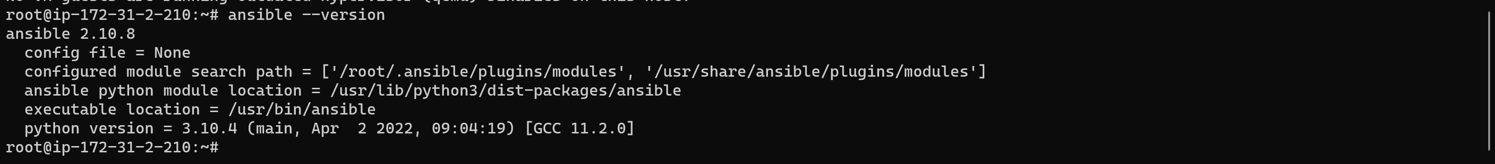

**Ansible is installed.**

**Creating Webserver EC2 instances**

**Pinging Web Servers 1 & 2 from Ansible Server instance 1**

**Ansible playbook webserver_deploy.yml display messages on port 8080 of webservers**

**Undeploy Web server resources**

